

Kazakh British Technical University
Almaty, Kazakhstan

SECOND SEMESTER
A.Y. 2019 – 2020

Blockchain technologies
SIS Lab #2 (deadline 26 April 0:00. Sunday)

Name: Sidakina Dana Talgatovna
Student ID: 17BD110508
Date: 12nd ofApril 2020

Please:

1) Complete the table.

 | Answer
What was goal of the lab (writing your first app) | We figured out how to write a smart contract on Fabric network. Also to make some transactions with updating the data.
What did you do at the lab – results | Started Fabric Network. Created ad Admin with key. By CA client we will check if Admin a;ready registered. If not , then Admin will be enrolled. Registered user with the same algorythm. Firstly, we got array of cars in database. Then made some changes in query.js and invoke.js and got one car, the car, which of the name we gave as argument to query.js. Aslo , with the same steps we created a car named “CAR12”, then got it in terminal by “node query.js”, before this we changed invoke.js. After what, we changed the owner of this car.
How it can be applied | In general, smart contracts will save human civilization from a significant part of paper workflow and protect the business from human errors and scammers. Smart contracts make it possible to carry out reliable and confidential transactions without the participation of external intermediaries in the person of banks or government bodies. In addition, such transactions are traceable, transparent and irreversible. Slock.It and Share & Charge  - new way of paying by smart-contracts.People can exchange, make payments or book a rental.  Allianz used smart contracts to automate insurance claims in the event of natural disasters.eGaaS is a platform trying to connect all state systems together using smart contracts and smart laws.

2) Attach screenshot
from the lab – 1st page of launched hyperledger code.

Screenshot must contain your name and data as well.
1)explanation on the next page
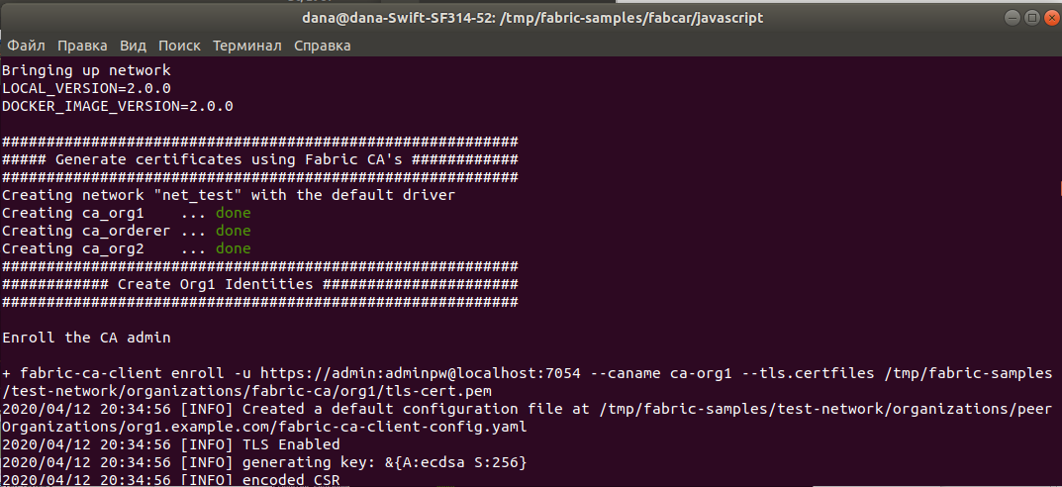

The command ./startNetwork.sh – started to create network with name “net_test”. Also in this network were created two peer named “ca_org1”, “ca_org2” and one service “ca_orderer”. We can see here that we brought up the “net_test” with CA. Also by this command created channel “mychannel” and org1 and org2 joined this channel, which means that they can communicate. Then channel was deployed by chaincode.

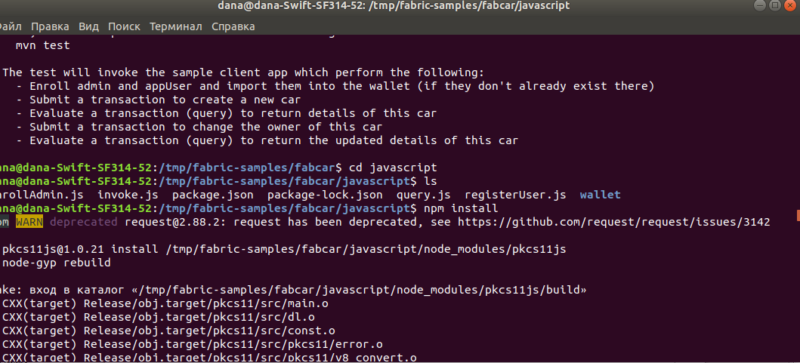
2)

cd javascript – moved to the javascript folder and saw those files. There’s a file named package.json where all dependencies are written. By command “npm install” we installed all of them.

3)
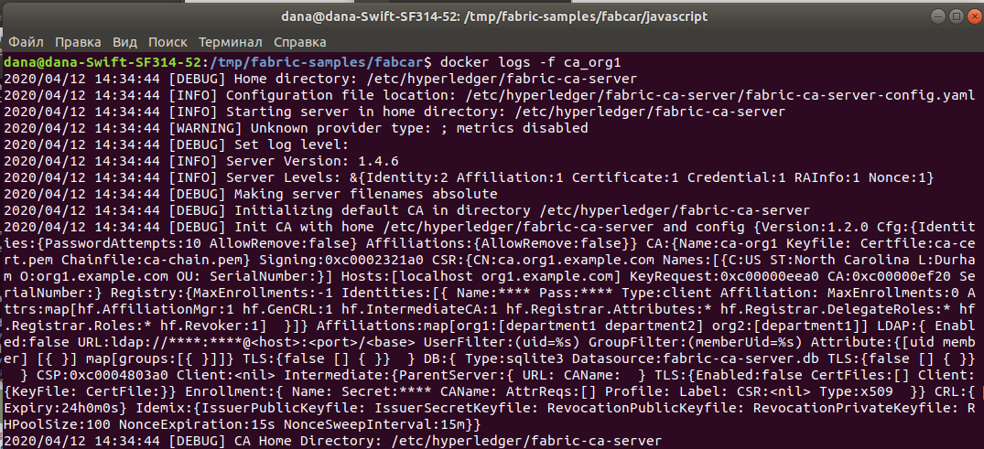

started to stream CA log, to understand what happens.

4)
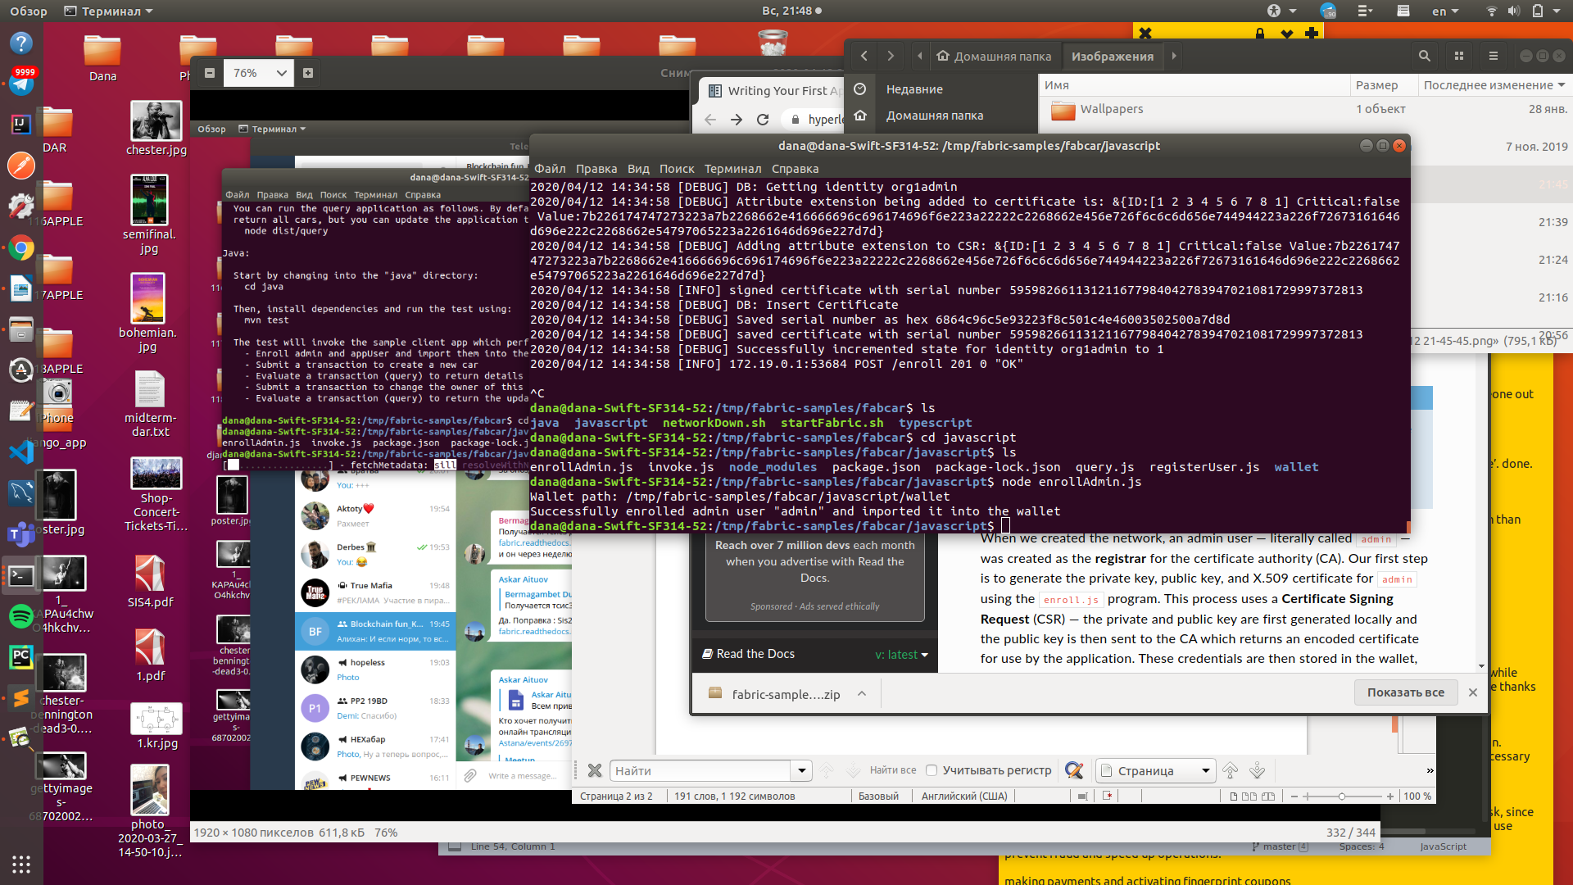

node enrollAdmin.js – this will created a wallet to enroll admin to out network, the id we can see in folder wallet=>admin.id;

5)
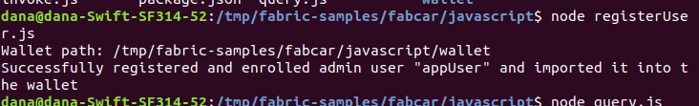

node registerUser.js -this will created a wallet for user to out network
6)
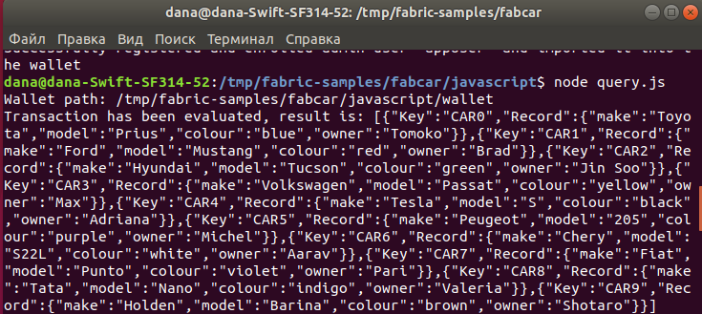

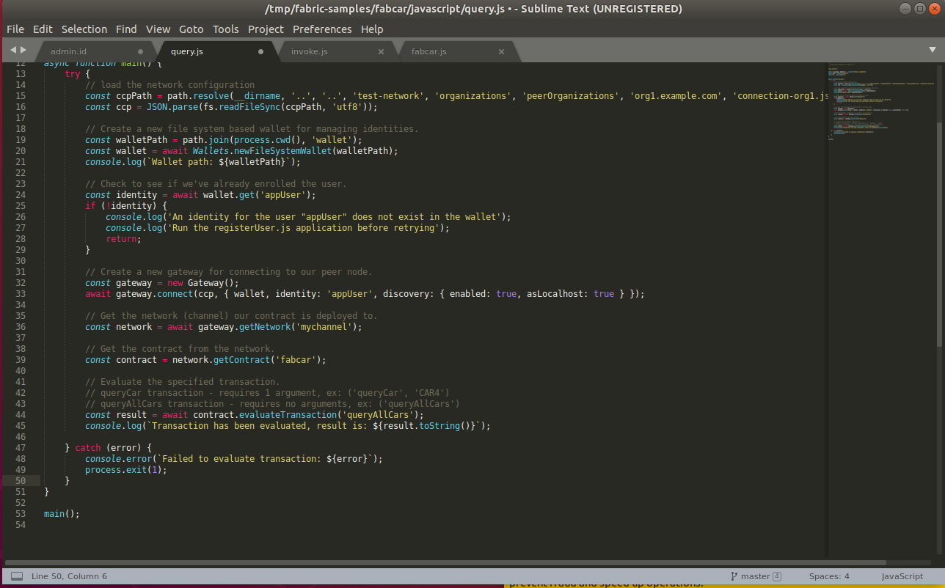

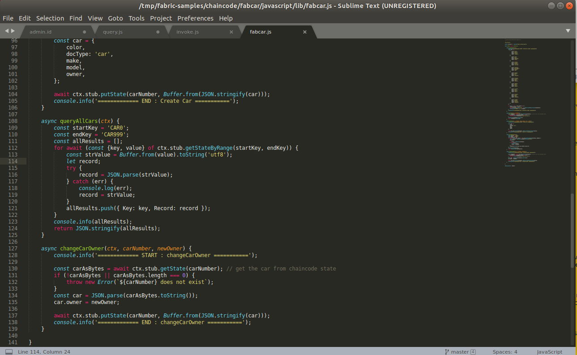

We used command “node query.js”, by this command we saw array of cars. Why array? Where it’s written? The request to get all cars is written in query.js on line 44. Result is “queryAllCars” , which is written in “fabcar.js”.

7)
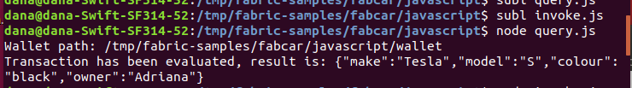

We changed request in invoke.js “getAllCars” to “getCar” and give one argument “C4”. And then used node.js to save.
After that, we used command “node query.js” which worked with updated invoke.js and gave us given result in image.

8)

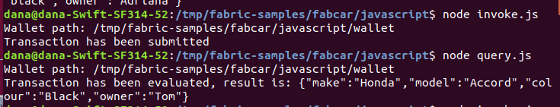

This time “node invoke.js” we used for updating out database. And we created a new car with command await contract.submitTransaction('createCar', 'CAR12', 'Honda', 'Accord', 'Black', 'Tom');
in invoke.js. “node query.js” gives result of this line in query.js const result = await contract.evaluateTransaction('queryCar','CAR12');

9)
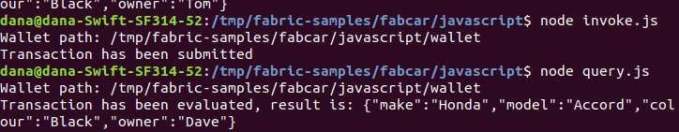

This time we updated base with just changing the owner of car, that we last time added.
await contract.submitTransaction('changeCarOwner', 'CAR12', 'Dave'); in invoke.js
const result = await contract.evaluateTransaction('queryCar','CAR12'); in query,js
and the owner of CAR12 changed from “Tom” to “Dave”.

10) just shut down the network.


